Sri Lanka Institute of Information Technology

Lab Submission

Lab sheet No: 06

**it**

**namr**

Probability and Statistics **|** IT2120

B.Sc. (Hons) in Information Technology

**Exercise**

**1)**

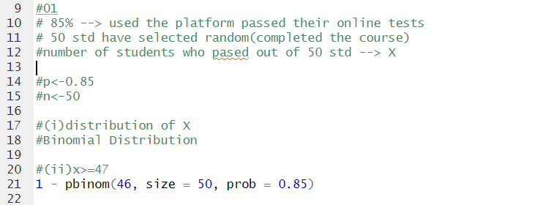

**2)**



